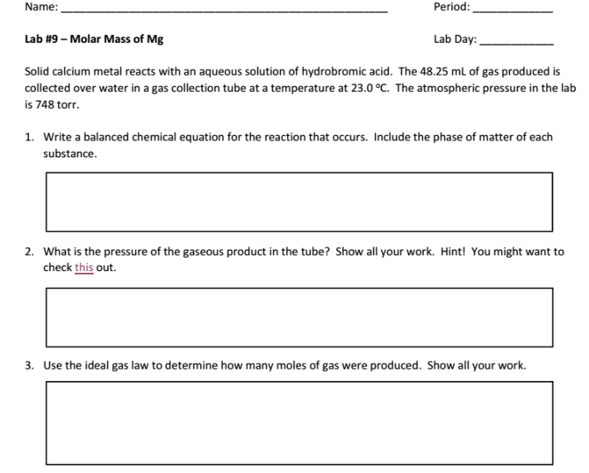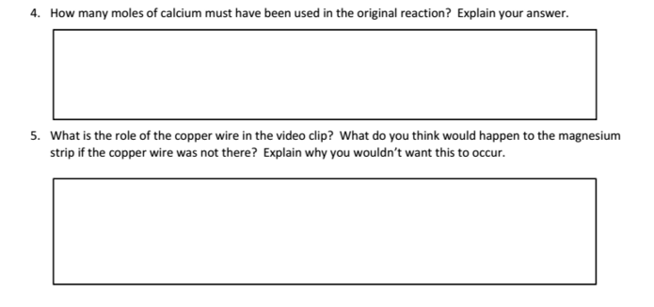

Ca(s) + 2HBr(aq) = CaBr2(aq) + H2(g)

The role of the copper wire is to hold the magnesium strip in place. If the copper wire was not in place, the magnesium strip might fall to the bottom of the gas tube where HCl will react with it and produce gas that will just leave the gas tube.

0.01897... moles of calcium must have been used in the original reaction because the ratio of Ca to H2 is 1:1. The amount of Ca on the reactants side in moles is the same amount of diatomic hydrogen molecules.

PV=nRT (726.3/760 atm)(48.25 / 1000 L)= n0.0821(23+273 K)

n= 0.01897... moles of H2

Vapor pressure of water at 23 Celsius is 21.7 torr. The atmospheric pressure is 748 torr. 21.07 torr + x = 748 torr. Solving for x yields 726.93 torr. of H2 pressure.

B2

5-6

Jonathan Quang